INL XXX-XX-XXXXX | NRIC 20-GDE-0001
Revision 1
Funded Project Planning Support

October 2021
Screening Process Details
Trina Davis

Funded Project Planning Support
The National Reactor Innovation Center's (NRIC) limited direct-funded project-planning support will be available to all qualifying organizations equally and will engage to provide information on NRIC and laboratory capabilities. NRIC will also assist reactor designers, as requested, in the identification of work packages and development of plans for their proposal.
Access to this resource will be available to organizations that provide NRIC with a preconceptual design document and a preliminary work-breakdown structure for the demonstration of an advanced nuclear energy technology, to demonstrate sufficient progress and commitment, as well as reasonable assurance that the team, partners, and affiliates will meet export control requirements. The Screening process and Screening questions are provided in Figure 1 and Table 1 below. Organizations may apply for NRIC Resource Team each laboratory fiscal year (FY) that it is offered for each qualified demonstration project. A brief statement or report of how the NRIC Resource Team benefitted their project in the past FY will be required if the Resource Team was utilized.
The level and type of NRIC assistance available will be well-defined, limited, and equally available to qualifying demonstration project teams.
NRIC will assist qualified teams with up to 200 hours of cumulative-subject matter expert (SME)/project-manager staff time, as available, in areas including but not limited to the following topics related to a demonstration project:
- Siting
- Fuels
- Licensing
- Modeling and Simulation
- Supporting infrastructure such as post-irradiation examination
- Digital engineering
- Safeguards and security
- Operations and training.
The 200 hours can be spread across those topics in whatever manner is most useful to the partner/team and can be sourced from a variety of national laboratories, coordinated through NRIC. There is no obligation to use NRIC or all 200 hours. Additional hours may be obtained through funded agreements or contracts.
When NRIC funds allocated to this activity are exhausted, this service will no longer be available.
The use of the following screening process, Figure 1, and the INL restricted-party screening tool, Table 1, will assist NRIC in matching qualifying projects with the NRIC assistance offered.

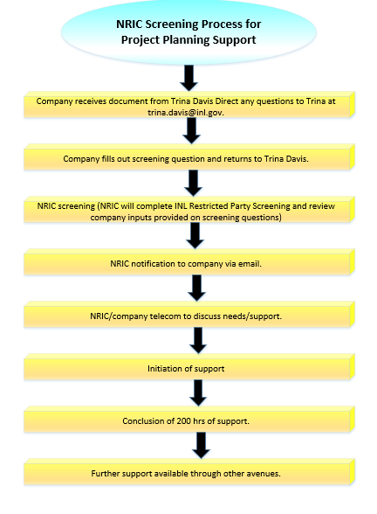
Figure 1. Screening Process.
Table 1. INL restricted-party screening tool.
Screening Questions
Project name: | Enter project name here
Project Owner/Submitter: | Enter project owner/submitter name
Date of submission: | Enter date of submission

Pre-conceptual Design: (Enter document title. Attach with submission; for renewals, verify that document submitted previously is still valid, or provide new documentation). | Enter name of document attached.

Work Breakdown Structure (WBS): (Enter document title. Attach with submission for renewals, verify that document submitted previously is still valid, or provide new documentation.) | File name for WBS structure.

ASSURANCES
Export Compliance Evaluation:
Does this project involve any work, funding, sponsorship, or oversight by non-U.S. governments, non-U.S. companies, or non-U.S. individuals? | Yes ☐ | No ☐
If yes, please explain which foreign countries will be involved and the nature of the involvement.Click or tap here to enter text.
Will the information resulting from this project be considered proprietary, confidential, or otherwise restricted from public distribution or publication? | Yes ☐ | No ☐
Please list all U.S. and non-U.S. companies or organizations involved with or funding this project. Click or tap here to enter text.
Does this project involve any technology related to nuclear explosive devices, chemical or biological weapons, missiles or that would be important to the design, construction, fabrication, operation, or maintenance of a uranium-enrichment, nuclear fuel-reprocessing, or heavy-water production facility? | Yes ☐ | No ☐

